CSA05-DATABASE MANAGEMENT SYSTEMS
LAB OBSERVATION
EXPERIMENT:07
AIM:
To view the records from the tables using SELECT commands with Group By, Having, Order By
QUESTION:
- How many students are registered for each course? Display the course description and the number of students registered in each course.
SQL QUERIES:
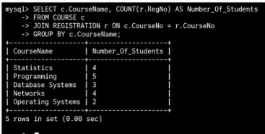
- How many courses did each student register for?
SQL QUERIES:
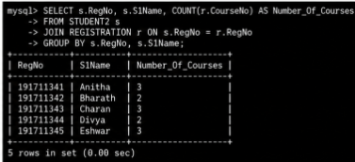
- Retrieve Name, Gender, Mobile No of all the students in ascending order of Reg No.
SQL QUERIES:
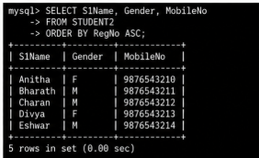
4. List the faculty members in the order of older faculty first.
SQL QUERIES:
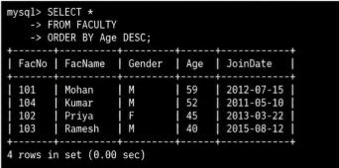
RESULT:
The records from the tables are displayed using SELECT commands with GROUP BY, HAVING and ORDER BY.

